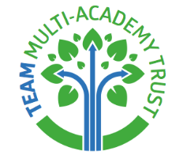

Brayford Academy

PSHE and RSE Policy

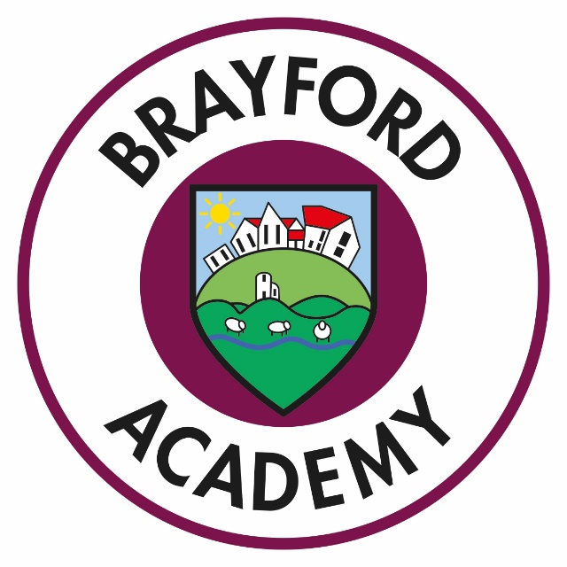


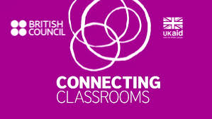

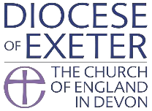


Vision and Values

Life, Love and Learning to the Full

At Brayford Academy we aim to build the foundations of life in all its fullness underpinned by our school values of Trust and Integrity, Enthusiasm and Creativity, Achievement and Aspiration, Mutual Respect and Friendship, where we understand what it means to be loved and to love others within our school and our local, national and global community.

Fundamental to our vision to educate for life in all its fullness, we are inspired to build our school community where all are valued, all contribute and all belong.
To achieve this, we work together on Building Learning Power, Building Communities, Building Self-Esteem and Building Futures.

Aims and Key Principles
Our school values underpin our ethos; every child is valued and encouraged to achieve their full potential. Every member of our school community is encouraged to respect and value each other. Wherever possible we make close links between our values and the PSHE curriculum.
Personal, social, health and economic education (PSHE) are an important and necessary part of all pupils’ education. Through a planned programme of learning, we aim to provide our pupils with the knowledge, understanding and skills that they need in order to manage their lives both now and in the future. As part of a whole school approach, we aim to develop the attributes our pupils need to thrive as individuals, as part of a family and as a confident member of the wider community.
We want our children to learn to understand and respect our common humanity, diversity and differences so that they can go on to form the effective, fulfilling relationships that are an essential part of life and learning.

Pupil Learning Intentions
We want our children to develop self-awareness, positive self-esteem and confidence, enabling them to:
- Have a sense of purpose
- Value self and others
- Form relationships
- Make and act on informed decisions
- Communicate effectively
- Work with others
- Respond to challenge
- Be an active partner in their own learning
- Be active citizens within the local community
- Explore issues related to living in a democratic society
- Become healthy and fulfilled individuals

Curriculum Content
PSHE (which includes Relationships and Sex Education) is taught weekly through a planned programme of work, called Jigsaw. The programme brings together PSHE Education, emotional literacy, social skills and spiritual development. Teaching strategies are varied and are mindful of preferred learning styles and the need for differentiation Jigsaw is designed as a whole school approach, with all year groups working on the same theme (Puzzle) at the same time.
We also aim to cover aspects of PSHE through special theme days and weeks e.g. Healthy Living week.
In addition to following the Jigsaw PSHE programme, opportunities for exploring aspects of PSHE will be capitalised upon e.g. through literacy sessions where a core text may involve questioning a character’s motivation for their actions etc.
Jigsaw covers all areas of PSHE for the primary phase, as the table below shows:

Term | Puzzle name | Content
Autumn 1: | Being Me in My World | Includes understanding my place in the class, school and global community as well as devising Learning Charters)
Autumn 2: | Celebrating Difference | Includes anti-bullying (cyber and homophobic bullying included) and diversity work
Spring 1: | Dreams and Goals | Includes goal-setting, aspirations, working together to design and organise fund-raising events
Spring 2: | Healthy Me | Includes drugs and alcohol education, self-esteem and confidence as well as healthy lifestyle choices
Summer 1: | Relationships | Includes understanding friendship, family and other relationships, conflict resolution and communication skills
Summer 2: | Changing Me | Includes Relationships and Sex Education in the context of looking at change

Learning and Teaching
In line with our Teaching and Learning Policy, a range of teaching strategies will be used to ensure that learning is purposeful, active and exciting. All pupils will work within a safe, secure climate to be able to explore their own and others’ attitudes, values and skills. Lessons will involve a high level of interaction where each pupil has planned opportunities for learning which will give them scope to work to their full potential.

Establishing a safe, open and positive learning environment based on trusting relationships between all members of the class, adults and children alike, is vital to successful and effective teaching and learning within this subject. Each class will establish ground rules largely based on the following:

- We take turns to speak
- We use kind and positive words
- We listen to each other
- We have the right to pass

Parental and Community Involvement
Parents are invited to join in events in school. Parents are regularly informed of events and developments on the website and school newsletter. We aim to involve outside agencies, including NSPCC, School Liaison Police Officer, dental health advisors, e-safety advisors, St Johns Ambulance service, to deliver aspects of the PSHE curriculum where possible.

Relationships and Sex Education (RSE) is taught in the summer term.

We recognise that Relationships and Sex Education is a sensitive subject but we firmly believe that effective RSE can make a significant contribution to the development of the personal skills needed by pupils if they are to establish and maintain relationships. It also enables children and young people to make responsible and informed decisions about their health and well-being.
Sensitivity and respect will be shown to all children when teaching about personal relationships and sex education and RSE is taught in a way to ensure that there is no stigmatization of children based on their home/personal circumstances.
Our RSE teaching and learning is set within a context that is consistent with the school’s ethos and values.
Whilst pupils are given the opportunity to explore their own attitudes, values and beliefs and to develop an individual moral code that will guide their actions, this is exercised within an understanding of the right of people to hold their own views within a framework of respect for others. We are educating our children to live in the real world with all its contradictions. Our focus is on building healthy attitudes and positive relationships in an environment where difference is celebrated and everyone is included and valued for who they are.

Jigsaw RSE Content
The grid below shows specific RSE learning intentions for each year group in the ‘Changing Me’ Puzzle.
Year Group | Piece Number and Name | Learning Intentions ‘Pupils will be able to…’
1 | Piece 2 Changing Me | Tell you some things about themselves that have changed and some things about themselves that have stayed the same.
2 | Piece 3 The Changing Me | Recognise how their bodies have changed since they were babies and where they are on the continuum from young to old.
2 | Piece 4 Boys and Girls Bodies | Recognise the physical differences between boys and girls and use the correct names for parts of the body (penis, anus, testicles, vagina, vulva) and appreciate that some parts of their bodies are private
3 | Piece 2 Babies | Understand how babies grow and develop in the mother’s uterus and understand what a baby needs to live and grow express how I might feel if I had a new baby in my family
3 | Piece 3  Outside Body Changes | Understand that boys’ and girls’ bodies need to change so that when they grow up their bodies can make babies identify how boys’ and girls’ bodies change on the outside during this growing up process recognise how I feel about these changes happening to me and know how to cope with those feelings
3 | Piece 4  Inside Body Changes | Identify how boys’ and girls’ bodies change on the inside during the growing up process and why these changes are necessary so that their bodies can make babies when they grow up recognise how I feel about these changes happening to me and how to cope with these feelings
4 | Piece 2 Having A Baby | Correctly label the internal and external parts of male and female bodies that are necessary for making a baby understand that having a baby is a personal choice and express how I feel about having children when I am an adult
4 | Piece 3  Girls and Puberty | Describe how a girl’s body changes in order for her to be able to have babies when she is an adult, and that menstruation (having periods) is a natural part of this know that I have strategies to help me cope with the physical and emotional changes I will experience during puberty
5 | Piece 2  Puberty for Girls | Explain how a girl’s body changes during puberty and understand the importance of looking after myself physically and emotionally  understand that puberty is a natural process that happens to everybody and that it will be OK for me
5 | Piece 3  Puberty for Boys and Girls | Describe how boys’ and girls’ bodies change during puberty  express how I feel about the changes that will happen to me during puberty
5 | Piece 4  Conception | Understand that sexual intercourse can lead to conception and that is how babies are usually made understand that sometimes people need IVF to help them have a baby appreciate how amazing it is that human bodies can reproduce in these ways
6 | Piece 2 Puberty | explain how girls’ and boys’ bodies change during puberty and understand the importance of looking after myself physically and emotionally express how I feel about the changes that will happen to me during puberty
6 | Piece 3  Girl Talk/Boy Talk | Ask the questions I need answered about changes during puberty  reflect on how I feel about asking the questions and about the answers I receive
6 | Piece 4  Babies – Conception to Birth | Describe how a baby develops from conception through the nine months of pregnancy, and how it is born recognise how I feel when I reflect on the development and birth of a baby
6 | Piece 5 Attraction | Understand how being physically attracted to someone changes the nature of the relationship express how I feel about the growing independence of becoming a teenager and am confident that I can cope with this

Withdrawal from RSE Lessons
Parents/carers have the right to withdraw their children from all or part of the Relationships and Sex Education provided at school except for those parts included in statutory National Curriculum Science. Those parents/carers wishing to exercise this right are invited in to see the head teacher and/or PSHE lead who will explore any concerns and discuss any impact that withdrawal may have on the child. Once a child has been withdrawn they cannot take part in the RSE programme until the request for withdrawal has been removed. Materials are available to parents/carers who wish to supplement the school RSE programme or who wish to deliver RSE to their children at home.

Teaching Sensitive and Controversial Issues
Sensitive and controversial issues are certain to arise in learning from real-life experience. Teachers will be prepared to handle personal issues arising from the work, to deal sensitively with, and to follow up appropriately, disclosures made in a group or individual setting. Issues that we address that are likely to be sensitive and controversial because they have a political, social or personal impact or deal with values and beliefs include: family lifestyles and values, physical and medical issues, financial issues, bullying and bereavement. Teachers will take all reasonable, practical steps to ensure that, where political or controversial issues are brought to pupils’ attention, they are offered a balanced presentation of opposing views. Teachers will adopt strategies that seek to avoid bias on their part and will teach pupils how to recognise bias and evaluate evidence. Teachers will seek to establish a classroom climate in which all pupils are free from any fear of expressing reasonable points of view that contradict those held either by their class teachers or their peers.

Training and Support for Staff
Support for teaching and understanding PSHE issues is incorporated in our staff INSET programme, drawing on staff expertise and/or a range of external agencies.

Assessment
Children’s understanding, knowledge and skills are assessed through observation, discussion, questioning and group participation. Children will be encouraged to talk about and reflect on their own experiences.

Monitoring and Evaluation

The TEAM PSHE subject leader will monitor delivery of PSHE through observation and discussion with teaching staff to ensure consistent and coherent curriculum provision. Evaluation will be based on:
- Pupil and teacher evaluation of the content and learning processes
- Staff meetings to review and share ideas

Confidentiality and Child Protection Issues
As a general rule a child’s confidentiality is maintained by the teacher or member of staff concerned. If this person believes that the child is at risk or in danger, she/he talks to the designated safeguarding lead who takes action as laid down in the Safeguarding Children Policy. All staff members are familiar with the policy and know the identity of the member of staff with responsibility for Child Protection issues. The child concerned will be informed that confidentiality is being breached and reasons why. The child will be supported by the teacher throughout the process.

TEAM Multi Academy Trust is committed to safeguarding and promoting the welfare of children and expects all staff and volunteers to share this commitment. The Safeguarding Children Policy and procedures are available on our website and provide comprehensive information regarding all forms of child exploitation.

Involving Parents and Carers
The school believes that it is important to have the support of parents, carers and the wider community for our PSHE teaching and learning programme and so will keep parents informed of the content studied using our termly curriculum newsletters, weekly school newsletters and annual end of year reports.

The parents section of our school website, “Keeping your child safe”, offers a wide range of advice and guidance to support parents.

