
5th September 2025

BRAYFORD ACADEMY NEWSLETTER
LIFE, LOVE AND LEARNING TO THE FULL

Dates and key information
~~~~
Please look out for further details of the following events which have been scheduled for this Spring term. These dates are an indication of what is to come, but may be subject to change as the term progresses and the need arises.

Dear Parents/Carers,

Welcome back to our families! I hope you had a lovely summer holiday. It has been lovely to hear all about the children's summer adventures.
A special welcome to our three new children Eva, Iris & Frankie. Thank you to our children for being so kind and friendly to our new children.
We also welcome Mr Pester to the junior class and Vicky in the kitchen.

We have exciting news to share! During the summer holiday Miss Prowse got married and she is now Mrs Connell! Huge congratulations to Mr and Mrs Connell!

There have been many changes in school over the summer. We now have lovely playground markings on the front playground which I am sure the children will enjoy. The library has moved to the main entrance and staff kindly spent time moving books, making bookshelves and ensuring this was an inviting space for our children
A huge thank you to Leah and Mrs Moore who have been very busy during the holidays! We now have a wonderful 'Lego Therapy Room', Creative Corner, breakfast club area and a newly painted cloakroom! The school looks fantastic and they have both spent their own time on making these spaces wonderful for our children.

Thank you to Burt, Zack and family for looking after our guinea pigs over the summer holidays, we really appreciate it.

Leah will now be running breakfast club for our school. Please could we ask that children are booked in by 12 the day before breakfast club is needed to ensure that we have correct staff ratios.

We are looking forward to an exciting term ahead with some lovely experiences planned for our children.

Miss Sara Leggott
Head of School
Brayford Academy

School Meals:
W/C Monday 8th September-Pink
Juniors= £2.58
Infants= Free
Brumbles=£2.00

Clubs
Mondays- Construction club KS1&2

Wednesdays- Book & a Biscuit Club All Ages Welcome!

Thursdays- Ukulele Club KS1&2

Clubs will be starting WC: 15/09/2025

P.E
Please could all children come into school in P.E kit every Wednesday. Children will not need uniform to change into.

Infants Forest School
Please can children come into school every Thursday in their Forest School kit. The children will need to bring in their uniform to get changed into afterwards.

Junior/ Brumble Bee Forest School
To Be Confirmed.

Why does Attendance Matter?
- Every day counts – Missing lessons can quickly add up and lead to gaps in learning.
- Builds friendships – Being in school helps children stay connected and maintain strong social bonds.
- Supports progress – Regular attendance is key to steady academic improvement.
- Promotes routine – A consistent routine helps pupils feel secure and ready to learn.

- Develops responsibility – Good attendance habits set the foundation for future success in school and beyond.

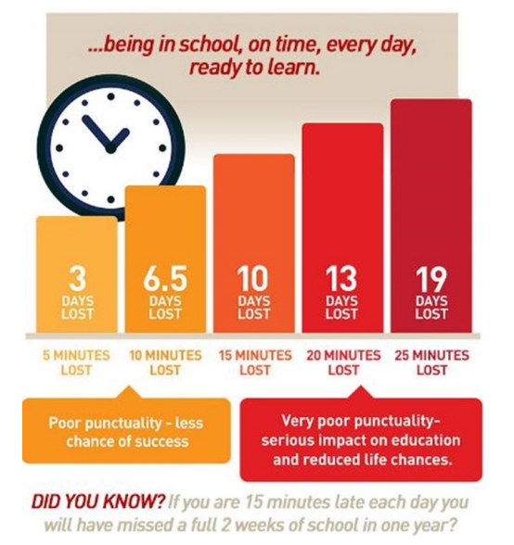
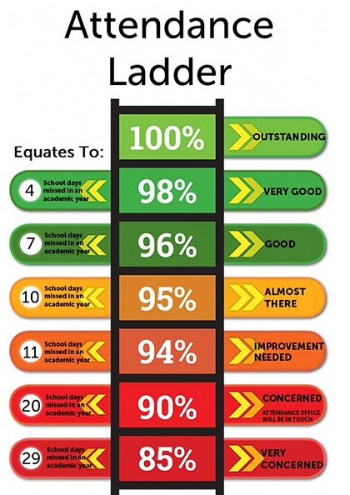



Certificate of Achievement
Juniors
Frankie- For his immersion in learning!
Iris- For her beautiful presentation!

Infants
Eva- For settling into her new class so well!

Menu w/c 8th September

MONDAY
Toad in The Hole
V: Veggie Sausages
Crispy Potatoes, Veg and Gravy
Sorbet

TUESDAY
Minced Beef Soft Tacos
V: No Meat Soft Tacos
Sweetcorn & Wedges
Fruit Jelly

WEDNESDAY
Roast of The Day
V: Homity Pie

Also available everyday:
Jacket potato with Tuna, Cheese or Beans
Yoghurt or Fresh Fruit

Cost of School Lunches:
Juniors - £2.58 per meal
Infants- Free
Brumbles- £2.00

Roast Potatoes & Veg
Apple Crumble

THURSDAY
Chicken Curry
V: Hidden Veg Quorn Curry
Naan Bread, Rice & Salad Sticks
Fruit Sponge & Custard

FRIDAY
Oven Baked Fish
V: Quorn Nuggets
Golden Fries & Veg
Shortbread Biscuit



Breakfast Club
Breakfast Club runs daily when required from 7.45am to 8.45am and is available to all children at the cost of £4.00 per child. If you would like your child to have some breakfast they need to arrive before 8.15am. There is support available with the cost if your child is in receipt of Pupil Premium.

Please pre-book sessions by midday the day before the required session through the school office.
Email: admin@brayford.devon.sch.uk
Phone: 01598 710345

- If your child is poorly, please report their absence to the school office on 01598 710345 by 9.30am.
- All medical appointments are to be advised in advance to the school office.
- Any other absences must be applied for via an absence request form.
- Please supply your child with a refillable drinks bottle every day.
- Warm coats for outdoor play if it’s wet or cold!
- Please park considerately in the Village hall car park for drop off and pickups.
- If your child is being collected by someone else, please ensure you email or phone the school office and let us know.



The School Office
Emails are only monitored between 8.30am and 12.00pm. If you need to speak to someone urgently, please call the school number 01598 710345. If no one answers, please leave a message and someone will contact you as soon as they can.

Any articles which appear in the school newsletter, that have not been organised by or on behalf of the school, have not been verified by TEAM Multi-Academy Trust as to the suitability for children. The news items are for parent information only.

