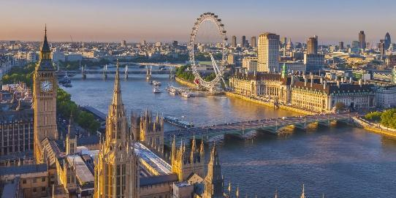
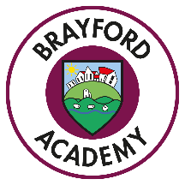
Infants

London Calling!

This term our topic is all about London. What do you know about England’s capital city? We will be finding out all about London, including its history, transport and famous landmarks. We will learn about Queen Elizabeth II, King Charles, the royal family and the great fire of London.

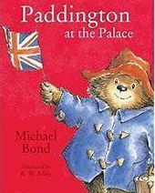
Literacy
We will be looking closely at fictional stories such as Paddington at the Palace, Paddington at the Zoo and Paddington at the Tower along with Katie in London as well as non-fiction books to find out lots about London Landmarks. Through fiction, non-fiction, and poetry genres, we will be writing non- chronological reports, character descriptions, poems, diary entries and stories based upon these texts. We will continue to learn to spell phonetically using our phonic sounds and continue to learn our spelling rules (Year 2). We will read a range of texts in our story times.
Reading
Children will develop their reading comprehension skills through participating in high-quality discussion with the teacher, as well as reading and discussing a range of stories, poems and non-fiction texts. Children will participate in whole class reading, with texts linked to our topic, and will learn to answer questions based on evidence from the text and making inferences on the basis of what is being said and done.

Maths
This half term we will continue to revisit and revise our core maths skills based on number and place value and the four operations (add, subtract, multiply and divide) Alongside this, in our maths lessons, we will be focusing on:
Year 1  Measurement length and height.  Weight and volume.  Fractions.  Geometry position and direction.  Time | Year 2  Measurement length and height.  Mass, capacity and temperature.  Geometry position and direction.  Time
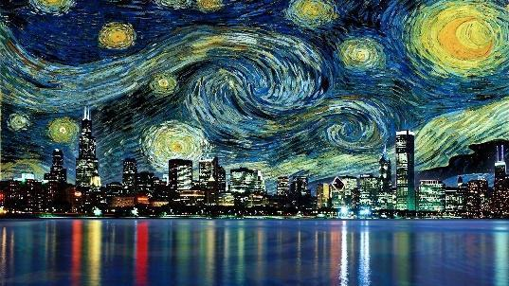
Science
In science we will be learning about animals and their habitats. Children will explore and compare the differences between things that are living, dead, and things that have never been alive. They will identify that most living things live in habitats to which they are suited and describe how different habitats provide for the basic needs of different kinds of animals and plants, and how they depend on each other. They will identify and name a variety of plants and animals in their habitats, including microhabitats.

Art and Design
We will continually practice our drawing skills across a range of topic lessons and will be creating some drawings of the famous London Landmarks. In our art lessons we will be focusing on the work of Andy Goldsworthy who rates art using natural objects. We will go outside to create our own art work using a variety of materials. For design and technology we will be cooking; making tea for the Queen and baking bread from Pudding Lane bakery.

PSHE
The focus is on keeping safe and belonging to a community. They will learn about being a part of different groups, about different rights and responsibilities that they have in school and the wider community. They will recognise that they are all equal, and ways in which they are the same and different to others in their community. They will learn how to recognise risk in everyday situations, e.g. road, water, rail safety and medicines. They will learn how to help keep themselves safe in familiar and unfamiliar environments, such as in school, online and ‘out and about’. They will identify potential unsafe situations, who is responsible for keeping them safe in these situations, and steps they can take to avoid or remove themselves from danger.
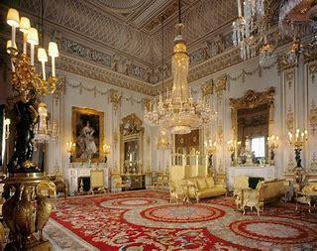
Computing
Different areas of learning will be enhanced using computing as they learn new skills to find out about areas of their topic. We will be looking at using the internet to find and copy images of London Landmarks and pictures related to The Royal Family. We will use the internet to explore the Royal UK website and navigate around virtual tours of Buckingham Palace and Royal homes.

RE
In RE this half term we will be discussing Creation. They will study different religious stories about the creation of the universe, including the Christian story from the Bible. They will be encouraged to question these beliefs and express their own views of how they think the world was made. They will learn about what different cultures as well as religions around the world believe about the natural world and its origins.
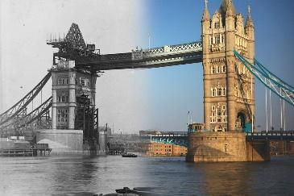
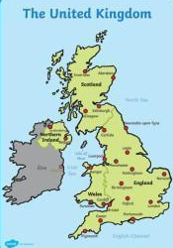
History
In history we will be learning about London, past and present, comparing the city from the 17th century to today. We will step back in time and discover what happened in the Great Fire of London; Where did it start? How did it end? We will look at London then and now; When did the famous landmarks get built? How did they get built? Why did they get built?

Geography
We will be looking at geographical similarities and differences through studying the human and physical features of a UK city, London, and the contrasting cities in India. We will learn about the 4 countries of the United Kingdom and locate them on a map, learning to use an atlas.

PE
Children will be focusing on athletics and striking and fielding games. In athletics they will explore running, jumping and throwing activities to develop their balance, agility and coordination as well as increasing their awareness of speed and distance.
French
Children will learn through songs and practical speaking activities, this term focusing on hobbies and interests.
Music
This term the children will be exploring the main elements of music (tempo, pitch, dynamics and timbre) through traditional stories.

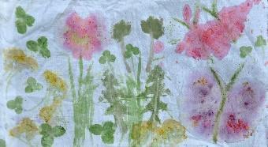
Outdoor learning
Children will learn a range of outdoor skills and knowledge through a wide variety of outdoor activities. This term children will be looking at animals and their habitats and using a ‘Go Pro’ camera to see what lies under the water in the pond!

We look forward to an exciting term ahead!
Miss Leggott & Mrs Joselin

