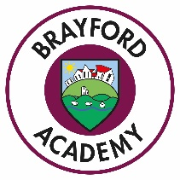

School Uniform
We have a smart and practical uniform that can be purchased from various outlets. The badged sweatshirt/cardigan and logo polo shirts can be purchased online at: http://www.brigade.uk.com/direct/index.php. We have a very limited amount of stock available to try on.
The Uniform Consists of:
- Maroon Sweatshirt, Fleece or Cardigan with School logo
- White Polo Shirt (available with logo if required)
- Grey or Black trousers, shorts, skirts or dresses
- Blue and striped or check dress in summer
- Flat Plain Black shoes (or closed toe sandals in the summer) Trainers are acceptable if they are plain black and robust.
For health and safety reasons, we do not allow children to wear jewellery except for a wrist watch and plain ear studs. Studs will need to be removed or taped for games and PE.

P.E
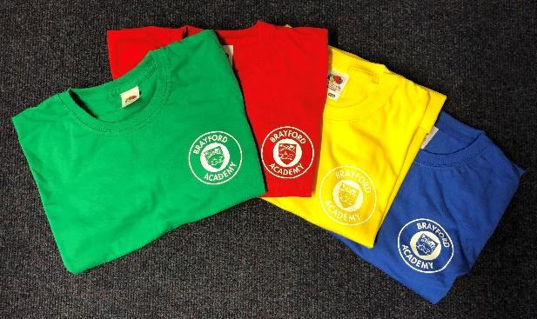
P.E T-shirts are available in 4 colours, Red, Yellow, Blue and Green.
Your child will be allocated a house colour.
T-shirts are only available to purchase from
the school office at a cost of £3.20.
- House Colour T-Shirt
- Black Shorts
- Trainers
- Black tracksuit bottoms for colder days

